**Activity 1 - Querying Data and Sorting Data**

**Exercise 1**

SQL Code:

SELECT * FROM locations;

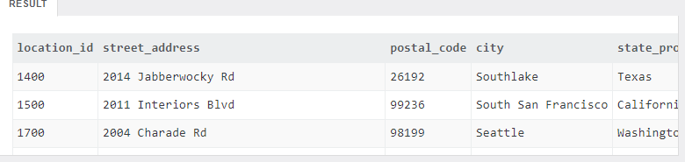

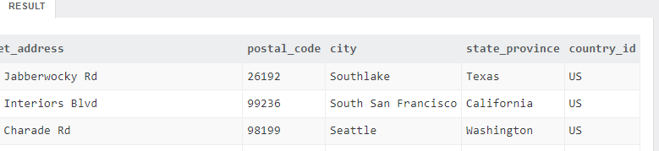

Total numbers of records: 7

SQL Code:

SELECT

location_id,

street_address,

city,

state_province

FROM

locations;

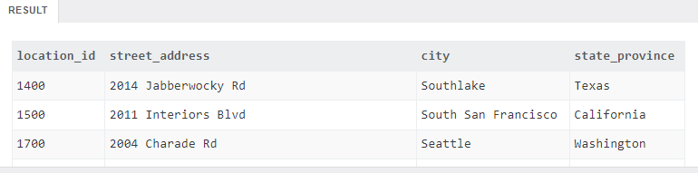

SQL Code:

SELECT

location_id,

city,

postal_code

FROM

locations;

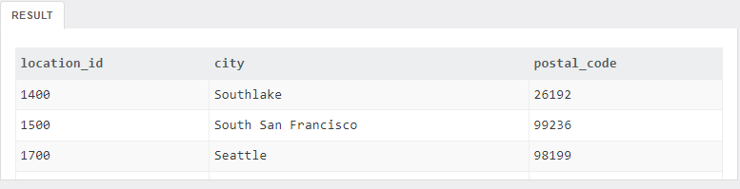

SQL Code:

select

l.location_id,

city,

postal_code as 'zip code'

from locations l;

**Exercise 2**

SQL Code:

SELECT

employee_id,

last_name,

salary

FROM

employees;

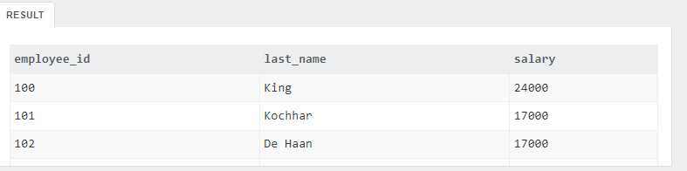

Total number of records: 40

SQL Code:

SELECT

e.employee_id,

last_name,

salary*12 as 'Yearly Salary'

FROM

employees e;

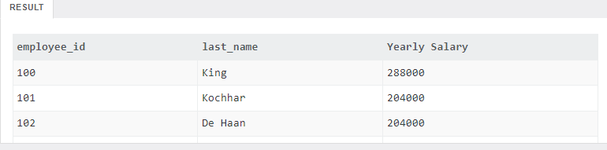

Date Diff function not working:

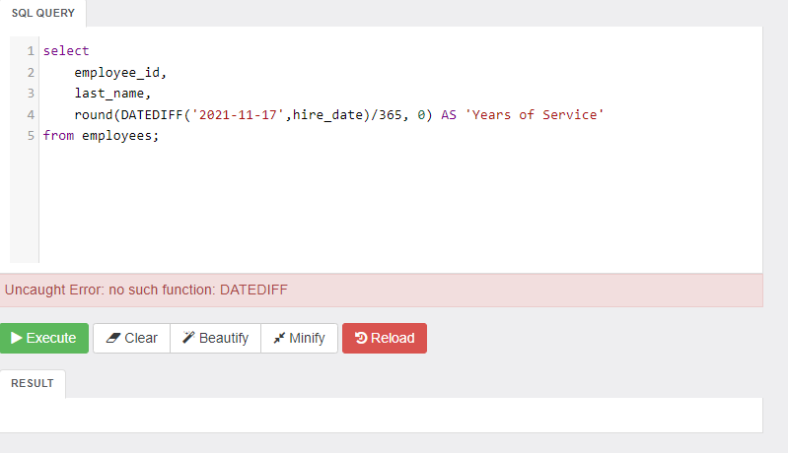

**Exercise 3**

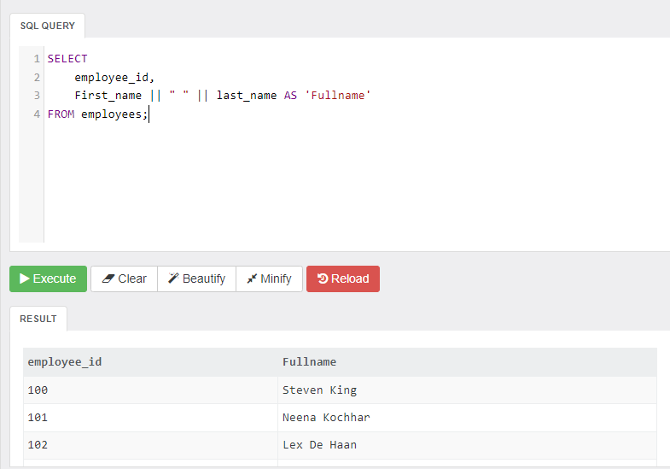

SQL Code:

select

country_id,

country_name,

region_id

FROM countries

order by country_name DESC;

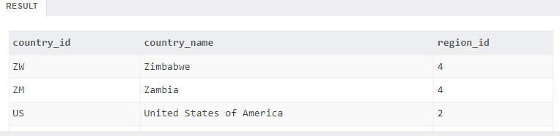

SQL Code:

SELECT

last_name,

first_name,

phone_number

FROM employees

order by last_name, first_name;

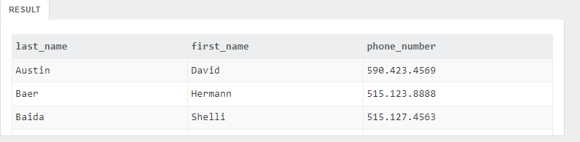

Exercise 4

SELECT

last_name,

salary,

email

FROM employees

ORDER BY

salary DESC,

last_name ASC;

